DB classes

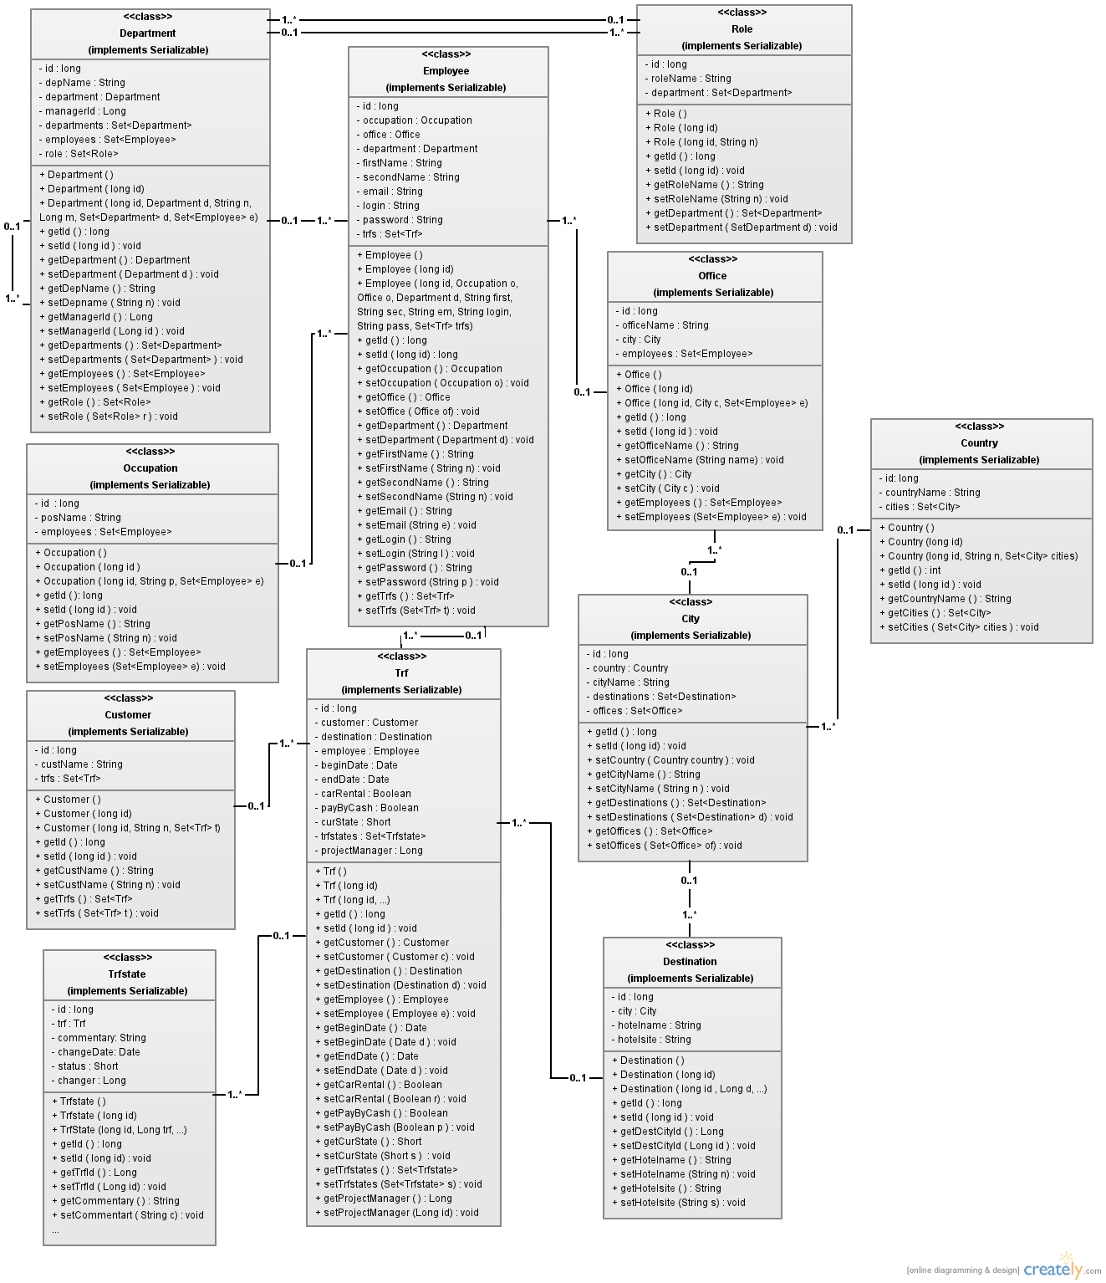

class Department:
general:
Represents some department of south american IT company HardoSoft. Can have parent department and/or child departments. Has number of roles (Common department, or Common and IT department, or Common and Travel Support department). Also has number of employees, who are working in this department.

attributes:
1) id (long) — identification number of department;
2) depName (String) — name of department;
3) department (Department) — parent department;
4) managerId (Long) — id of department's manager;
5) departments (Set<Department>) — child departments of this department;
6) employees (Set<Employee> ) - employees who are working in this department;
7) role (Set<Role> ) - roles which this department have.

methods:
getters and setters to each attribute.

class Role:
general:
Represents role (Common department, IT department, Travel Support department) which every HardoSoft department can have.

attributes:
1) id (long) — identification number of role;
2) roleName (String) — name of role;
3) department (Set<Department>) — departments which have this role.

methods:
getters and setters to each attribute.

class Employee:
general:
Represents some employee of south american IT company HardoSoft. Employee has occupation, has private information (first name, second name, e-mail), is assigned to some department and office. Also there is login and password that are used by employee while being on HardoSoft travel portal, and number of trips (in TRF format) in which this employee was/is involved.

attributes:
1) id (long) — identification number of employee;
2) occupation (Occupation) — post which employee is occupying;
3) office (Office) — office to which employee is assigned;
4) department (Department) — department to which employee is assigned;
5) firstName (String) — first name of employee;
6) secondName (String) — second name of employee;
7) email (String) — e-mail of employee;
8) login (String) — login which employee is using while being on HardoSoft travel portal;
9) password (String) — password which employee uses to pass authentication on HardoSoft travel portal;
10) trfs (Set<Trf>) - trips (in trf form) in which employee is involved.

methods:
getters and setters to each attribute.

class Occupation:
general:
Represents post which employee of IT company HardoSoft can occupy. Has numbers of employees, who are occupying this post.

attributes:
1) id (long) — identification number of post;
2) posName (String) — name of position;
3) employees (Set<Employee> ) - employees who are occupying this post;

methods:
getters and setters to each attribute.

class Office:
general:
Represents some office of south american IT company HardoSoft. Every office is located in particular city and has number of employees assigned to it.

attributes:
1) id (long) — identification number of office;
2) officeName (String) — name of office;
3) city (City) — city in which this office is located;
4) employees (Set<Employee> ) - employees who are working in this office;

methods:
getters and setters to each attribute.

class City:
general:
Represents some city, in which some HardoSoft office is located or to which some employee business trip planned.

attributes:
1) id (long) — identification number of this city;
2) country (String) — country in which this city is located;
3) cityName (String) — name of city;
4) destinations (Set<Destination>) — destinations (trips), where destination city is this city;
5) offices (Set<Office> ) - offices which are located in this city;

methods:
getters and setters to each attribute.

class Country:
general:
Represents some country, in which some HardoSoft office is located or to which some employee business trip is planned.

attributes:
1) id (long) — identification number of country;
2) countryName (String) — name of country;
3) cities (Set<City>) - cities which are located in this country. This cities are either locations of HardoSoft offices, or destinations in employees business trips.

methods:
getters and setters to each attribute.

class Destination:
general:
Represents destination (city and hotel) to which some employees business trip is planned.

attributes:
1) id (long) — identification number of destination;
2) city (City) — destination city;
3) hotelname (String) — name of hotel in which employee will be placed;
4) hotelsite (String) — site of hotel in which employee will be placed;

methods:
getters and setters to each attribute.

class Trf:
general:
Represents a business trip information. It is a main entity on travel portal, all project and travel support managers are working with it.

attributes:
1) id (long) — identification number of trf;
2) customer (String) — customer whose project obligates employee to make this trip.
3) destination (Destination) — trip destination (city and hotel);
4) employee (Employee) — employee who is making this trip;
5) beginDate (Date) — date when trip starts;
6) endDate (Date) — date when trip ends;
7) carRental (Boolean) — shows if employee needs car rental;
8) payByCash (Boolean) — shows if trip is payed by cash;
9) curState (Short) — shows current state of Trf (entering, ready, rejected,completed, or cancelled)
//0 — entering, 1 — rejected, 2 — cancelled, 3 — ready, 4 - completed
10) trfstates (Set<Trfsttate) — all states which this trf has passed (with information on each change);
11) projectManager (Long) — id of employer's project manager.

methods:
getters and setters to each attribute.

class Customer:
general:
Represents HardoSoft customer (some company), working with which HardoSoft should send it's employees in business trips.

attributes:
1) id (long) — identification number of customer;
2) custName (String) — customer's name;
3) trfs (Set<Trf>) - trips for employees, who are working on this customer's projects.

methods:
getters and setters to each attribute.

class Trfstate:
general:
Represents state which some trf has passed. Has additional information about reasons why trf had this state and who made such change.

attributes:
1) id (long) — identification number of trf state;
2) trf (Trf) — trf which had this state;
3) commentary (String) — commentary which was made by state changer;
4) changeDate (Date) — date when change was made;
5) status (Short) — status which was assigned to trf;
//0 — entering, 1 — rejected, 2 — cancelled, 3 — ready, 4 - completed
6) changer (Long) — id of employee who made change.

methods:
getters and setters to each attribute.

